**Course Code: ITA0447**

**Course Title: STATISTICS WITH R PROGRAMMING FOR NLP**

**LAB DAY : 02**

1. Write a R program to find the factors of a given number.

CODE:

find_factors <- function(num) {

factors <- c()

for (i in 1:num) {

if (num %% i == 0) {

factors <- c(factors, i)

}

}

return(factors)

}

num <- 20

factors <- find_factors(num)

cat(paste("The factors of", num, "are:", factors))

OUTPUT:



1. Write a R program to find the maximum and the minimum value of a given vector.

CODE:

vec <- c(10, 50, 30, 70, 20, 90)

max_val <- max(vec)

cat("Maximum value in vector is:", max_val, "\n")

min_val <- min(vec)

cat("Minimum value in vector is:", min_val, "\n")

OUTPUT:

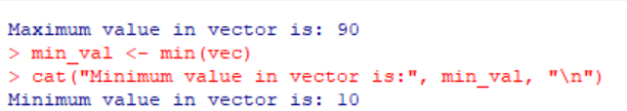

1. Write a R program to get the unique elements of a given string and unique numbers of vector.

CODE:

my_string <- "hello world"

unique_chars <- unique(strsplit(my_string, "")[[1]])

print(unique_chars)

my_vector <- c(1, 2, 3, 4, 3, 2, 1)

unique_numbers <- unique(my_vector)

print(unique_numbers)

OUTPUT:

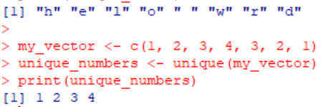

1. Write a R program to create three vectors a,b,c with 3 integers. Combine the three vectors to become a 3×3 matrix where each column represents a vector. Print the content of the matrix.

CODE:

a <- c(1,2,3)

b <- c(4,5,6)

c <- c(7,8,9)

matrix <- cbind(a,b,c)

print(matrix)

OUTPUT:

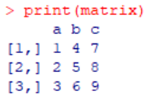

1. Write a R program to create a list of random numbers in normal distribution and count occurrences of each value.

CODE:

set.seed(123)

random_numbers <- rnorm(100, mean = 0, sd = 1)

occurrences <- table(random_numbers)

print(occurrences)

OUTPUT:

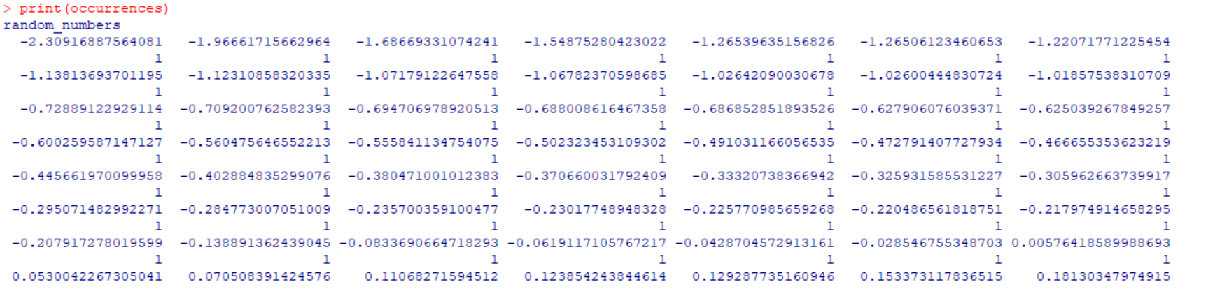

1. Write a R program to read the .csv file and display the content.

CODE:

setwd("C:/programfile/user/onedrive/r ")

my_data <- read.csv("sport.csv")

print(my_data)

OUTPUT:

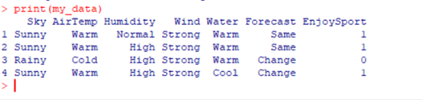

1. Write a R program to create three vectors numeric data, character data and logical data. Display the content of the vectors and their type.

CODE:

numeric_vector <- c(1, 2, 3, 4, 5)

char_vector <- c("apple", "banana", "cherry", "date", "elderberry")

logical_vector <- c(TRUE, FALSE, TRUE, TRUE, FALSE)

cat("Numeric vector:", numeric_vector, "\n")

cat("Character vector:", char_vector, "\n")

cat("Logical vector:", logical_vector, "\n")

cat("Data type of numeric vector:", typeof(numeric_vector), "\n")

cat("Data type of character vector:", typeof(char_vector), "\n")

cat("Data type of logical vector:", typeof(logical_vector), "\n")

OUTPUT:

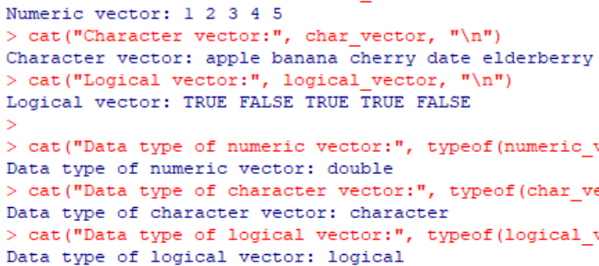

1. Write a R program to create a 5 x 4 matrix , 3 x 3 matrix with labels and fill the matrix by rows and 2 × 2 matrix with labels and fill the matrix by columns.

CODE:

mat1 <- matrix(c(1,2,3,4,5,6,7,8,9,10,11,12,13,14,15,16,17,18,19,20), nrow=5, ncol=4, byrow=TRUE)

rownames(mat1) <- c("Row1", "Row2", "Row3", "Row4", "Row5")

colnames(mat1) <- c("Col1", "Col2", "Col3", "Col4")

print(mat1)

mat2 <- matrix(c(1,2,3,4,5,6,7,8,9), nrow=3, ncol=3, byrow=TRUE)

rownames(mat2) <- c("RowA", "RowB", "RowC")

colnames(mat2) <- c("ColX", "ColY", "ColZ")

print(mat2)

mat3 <- matrix(c(1,2,3,4), nrow=2, ncol=2, byrow=FALSE)

rownames(mat3) <- c("Row1", "Row2")

colnames(mat3) <- c("ColA", "ColB")

print(mat3)

OUTPUT:

